**WEEK-1 ALGORITHMS AND DATA STRUCTURES**

**Exercise 1: Inventory Management System**

**Significance of Data Structures and Algorithms:**

* Efficient data storage and retrieval mechanisms are necessary for maintaining quick access times when handling large inventories.
* The right data structures guarantee the system can manage growing volumes of data without notable loss in performance.
* Optimization involves using effective algorithms to reduce the amount of computational resources needed for tasks like searching, adding, updating, and deleting items in inventory.

**Appropriate Types of Data Structures:**

**ArrayList** is suitable for managing a collection of products, simple to loop through, yet not as effective for searching and removing items.

**HashMap** allows for efficient inventory management by providing an average time complexity of O(1) for add, update, and delete operations.

**Analysis of the complexity over time:**

* Inserting elements into a HashMap has a time complexity of O(1), resulting in constant time for this operation.
* Updating a HashMap element by key is an O(1) operation, meaning it is of constant time complexity.
* Deletion: O(1) - Erasing a key in a HashMap takes constant time.

**Improvements:**

* Utilize indexing for common searches or queries.
* Modify the load factor of the HashMap to find a middle ground between space and time complexities.
* In environments with multiple threads, ConcurrentHashMap can be used.

**Exercise 2: E-commerce Platform Search Function**

Big O Notation:

* Big O Notation describes the upper bound of the time complexity of an algorithm, giving us an idea of the worst-case scenario in terms of performance as the input size grows.
* It helps in analyzing and comparing the efficiency of different algorithms.

**Scenarios for Search Operations:**

* Best Case: The scenario where the search operation finds the desired element on the first attempt.
* Average Case: The scenario where the search operation takes a middle-ground number of steps to find the desired element.
* Worst Case: The scenario where the search operation has to go through all elements to find the desired element or determine it's not in the dataset

**Time Complexity comparison:**

* Linear Search: Time Complexity is O(n), where n is the number of products. It checks each product one by one.
* Binary Search: Time Complexity is O(log n), where n is the number of products. It repeatedly divides the search interval in half.

**Suitable Algorithm:**

* Linear Search: Simple to implement and does not require sorted data. Suitable for small datasets.
* Binary Search: More efficient for larger datasets but requires sorted data. Suitable for larger datasets where search speed is critical.

**Exercise 3: Sorting Customer Orders**

**Bubble Sort:**

* Bubble Sort is a simple comparison-based sorting algorithm where each pair of adjacent elements is compared, and the elements are swapped if they are in the wrong order. This process is repeated until the array is sorted.
* Time Complexity: O(n^2) for both average and worst cases.

**Insertion Sort:**

* Insertion Sort builds the final sorted array one item at a time. It is much less efficient on large lists than more advanced algorithms such as quicksort, heapsort, or merge sort.
* Time Complexity: O(n^2) for both average and worst cases.

**Quick Sort:**

* Quick Sort is a divide-and-conquer algorithm. It works by selecting a 'pivot' element from the array and partitioning the other elements into two sub-arrays, according to whether they are less than or greater than the pivot.
* Time Complexity: O(n log n) on average, but O(n^2) in the worst case.

**Merge Sort:**

* Merge Sort is a divide-and-conquer algorithm that divides the array into two halves, sorts them, and then merges the sorted halves.
* Time Complexity: O(n log n) for both average and worst cases

**Compare Performance (Time Complexity):**

* Bubble Sort: O(n^2) for both average and worst cases. Not suitable for large datasets due to its inefficiency.
* Quick Sort**:** O(n log n) on average, but O(n^2) in the worst case. Generally much faster than Bubble Sort for large datasets.

**Advantages of performing QuickSort:**

* Quick Sort is generally preferred over Bubble Sort because it has a much better average-case time complexity (O(n log n)) compared to Bubble Sort's O(n^2).
* Quick Sortperforms significantly better for large datasets, making it more suitable for real-world applications like sorting customer orders on an e-commerce platform.

**Exercise 4: Employee Management System**

**Array Representation in Memory:**

* Arrays are a contiguous block of memory where each element is stored sequentially.
* Each element in the array can be accessed directly via its index, making arrays efficient for indexing operations.

**Advantages:**

* + Direct Access: O(1) time complexity for accessing elements.
  + Ease of Use: Simple data structure for storing a collection of elements.
  + Memory Efficiency: Minimal overhead compared to more complex data structures.

**Analyze Time Complexity of Each Operation:**

* Add Employee: O(1) - Direct insertion if there's space in the array.
* Search Employee: O(n) - Linear search through the array.
* Traverse Employees: O(n) - Linear traversal of the array.
* Delete Employee: O(n) - Linear search to find the employee, followed by shifting elements.

**Limitations of Arrays:**

* Fixed Size: Arrays have a fixed size, which can limit scalability and flexibility.
* Insertion and Deletion: Inserting or deleting elements can be inefficient because it may require shifting elements.
* When to Use: Arrays are useful for small to medium-sized datasets where the size is known and infrequent insertions and deletions are needed

**Exercise 5: Task Management System**

**Types of Linked Lists:**

* Singly Linked List: Each node contains data and a reference (or pointer) to the next node in the sequence. The last node points to null.
  + Advantages: Simple structure, easy to implement.
  + Disadvantages: No backward traversal, can be inefficient for certain operations.
* Doubly Linked List: Each node contains data, a reference to the next node, and a reference to the previous node.
  + Advantages: Allows for forward and backward traversal.
  + Disadvantages**:** More complex, requires more memory due to extra pointer

**Time Complexity of Each Operation:**

* Add Task: O(n) - Traverse to the end of the list and add the new task.
* Search Task: O(n) - Linear search through the list.
* Traverse Tasks: O(n) - Linear traversal of the list.
* Delete Task: O(n) - Linear search to find the task, then update pointers.

**Advantages of Linked Lists Over Arrays:**

* Dynamic Size: Linked lists can grow and shrink in size dynamically, unlike arrays which have a fixed size.
* Efficient Insertions/Deletions: Insertions and deletions are generally more efficient as they only require updating pointers, not shifting elements as in arrays.
* Use Cases: Linked lists are useful when the size of the data set is unknown or when frequent insertions and deletions are required.

**Exercise 6: Library Management System**

**Linear Search:**

* Linear search is a straightforward search algorithm where each element in the list is checked sequentially until the target element is found or the list ends.
* Time Complexity: O(n) in both average and worst-case scenarios.

**Binary Search:**

* Binary search is an efficient algorithm for finding an element in a sorted list. It works by repeatedly dividing the search interval in half. If the value of the target element is less than the middle element of the interval, the search continues in the lower half, or if greater, in the upper half.
* Time Complexity**:** O(log n) in both average and worst-case scenarios.

**Compare Time Complexity:**

* Linear Search: O(n) - Each element is checked sequentially.
* Binary Search: O(log n) - The search interval is halved with each step, making it much more efficient for large, sorted lists.

**When to Use Each Algorithm:**

* Linear Search: Suitable for small datasets or when the data is unsorted. Simple to implement and does not require sorting.
* Binary Search: Ideal for large datasets where the data is sorted. Much more efficient than linear search but requires the list to be sorted first.

**Exercise 7: Financial Forecasting**

**Recursion** is a technique where a method calls itself to solve a problem. A problem is broken down into smaller, more manageable sub-problems that resemble the original problem.

Base Case: A condition under which the recursion stops. This is crucial to prevent infinite recursion.

Recursive Case: The part where the method calls itself to handle a smaller portion of the problem.

**Advantages:**

* Simplifies code for problems that have a natural recursive structure (e.g., tree traversal, factorial computation).
* Can make complex problems more manageable.

**Complexity:**

* Time Complexity: O(n), where n is the number of years. This is because the recursive method is called once for each year.
* Space Complexity**:** O(n) due to the recursion stack, which grows with the number of recursive calls.

**Optimize the Recursive Solution:**

* Memoization: Store results of sub-problems to avoid redundant calculations. However, for a simple recursive future value calculation like this, memoization might not be necessary.
* Iterative Approach**:** In cases where recursion depth can become an issue, consider converting the recursive algorithm to an iterative one to avoid deep recursion and excessive stack usage.

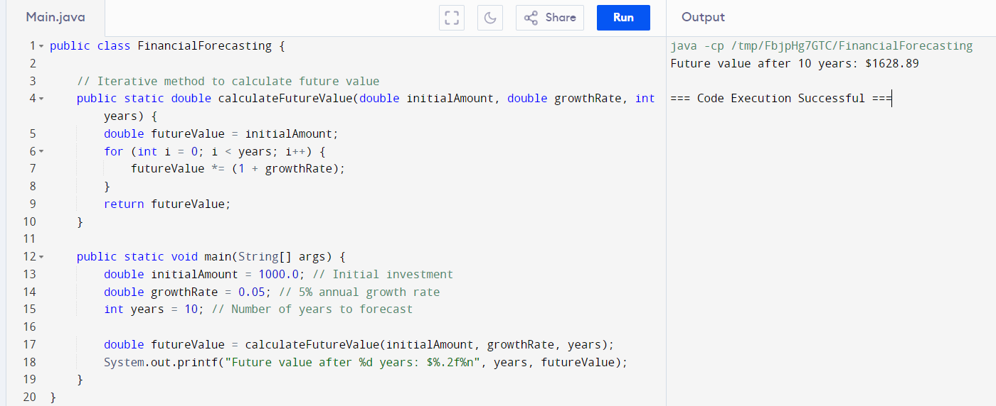

**Advantages of Iterative Approach:**

* Avoids Stack Overflow: Iterative solutions do not have the risk of stack overflow that recursive solutions might have for very deep recursion.
* Potentially More Efficient: For certain problems, iterative solutions can be more memory-efficient and faster.